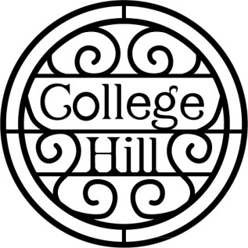

**College Hill Neighborhood Association**

Annual Meeting Agenda – Monday, September 18, 2023

1. Guest Speakers – City Council District 6 Candidates Craig Dunstan and Marcus Miller
2. Update on College Hill street improvements for pedestrians
3. Minutes from the July 17, 2023 meeting
4. Treasurer’s Report
5. Reports - Night Out Against Crime on August 5. Recycling drive - Carol Christensen. Boswell Park projects – Laura Burton. Partnership for a Blessing Box for College Hill at Westminster Church.
6. Old Business
7. New Business
8. Our next meeting is 7 p.m., Monday, Nov. 20, 2023 at Westminster Church

**Mark your calendars- Saturday recycling drive is December 9**