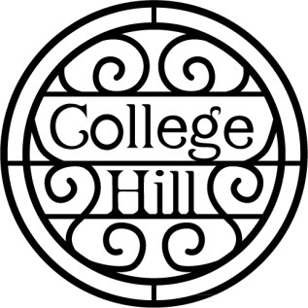
College Hill Neighborhood Association
Round Table Agenda– January 11, 2021
- Introductions
- Minutes
- Treasurer’s Report
- Operation Food Secure in College Hill – Brett Martin
- Topeka Community Acceptance Grant for light bulbs UPDATE – Andy Fry
- Recycling Drive - Carol Christensen
- Old Business – Updates on Blossoms, Clean Up Day, July 4 Celebration, College Hill stones, Bricks in Boswell Park
- New Business
- Our next meeting is Monday, July 19, 2021. We will meet at Westminster Presbyterian Church.
Mark your calendars:
Recycling days – July 10, September 11 and December 11
National Night Out Against Crime – August 7
College Hill Garage Sale – June 3-5 OR June 10-12

