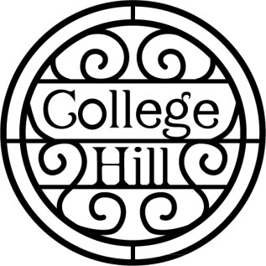
College Hill Neighborhood Association
Round Table Agenda– January 11, 2021
- Introductions
- Minutes
- Treasurer’s Report
- New Business – Introduction of any visitors
- Operation Food Secure in College Hill – Brett Martin
- Trailer Purchase Discussion for CHNA – Brett Martin
- Topeka Community Acceptance Grant for light bulbs – Andy Fry
- Recycling drive – update by Carol Christensen
- Traffic calming projects – and vote of acceptance – Andy Fry
- Kansas Leadership Center Grant for internet equipment and one year of service in Boswell Park for COVID related challenges – Andy Fry
- Old Business
- New Business
- Our next meeting is March 15, 2021. We will meet at Westminster Presbyterian Church or on Zoom.

