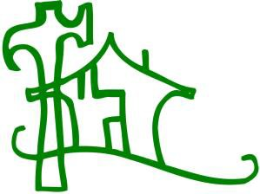
Christmas in Action
Topeka Inc.
Building Hope in our Community
1880 SW Gage Topeka, Kansas 66604 (785) 272 0749

PRESS RELEASE PRESS RELEASE PRESS RELEASE

Christmas in Action Topeka Inc. (C in A) is now accepting applications for the April 2019 minor home repair projects. To qualify a person must live in Topeka or Shawnee County, be elderly (over 60 years old), own their home and be low income. All applications must be post marked by December 15, 2018.

For more information or if you think you qualify, you may obtain an application by calling C in A at
(785) 272-0749. Please speak slowly, leave your name and phone number. A volunteer will call you for additional information. .

